CHECK OUT COLORADO SPRINGS

Colorado Springs is the second largest city in Colorado. Just over an hour south of Denver, it is home to stately Pikes Peak and a variety of outdoor adventures. No matter which season you’re visiting Colorado Springs, you’ll enjoy the many lovely natural surroundings and cultural attractions it offers.

(MARKET IMAGE HERE)

Find Deals From These Cities

INSERT FARE GRID FROM / TO Version (if available!)

   
Top Things To Do in Colorado Springs

Below are some things you won’t want to miss. Be sure to include these on your “what to see in Colorado Springs” list!

* Be an Olympian for a day. Well, not exactly. But you can do the next best thing and take a free tour at the U.S. Olympic Complex to see where Olympians train. While you’re there, visit the U.S. Olympic Hall of Fame, and make sure you get to the rooftop terrace to see the gorgeous panoramic views of the entire complex and of Colorado Springs.
* Explore Garden of the Gods, a registered national landmark that has some of the most amazing scenery in Colorado, including unique rock formations and great views of Pikes Peak. While you can take a car along a paved loop through the park, the experience you’ll get from taking one of the many paved walking, hiking, mountain biking and horseback riding trails can’t be beat.
* Experience the energy at Ivywild School, a 1916 elementary school renovated into a lively community market. You’ll find a fabulous variety of delicious goodies - from fresh baked pastries and locally grown produce, to great coffee and craft-brewed beer. Check out the “public square” for any special events that may be happening when you visit.

Travel Tips and Resources

[Must-Dos in Colorado Springshttp://www.tripadvisor.com/Attractions-g33364-Activities-Colorado_Springs_El_Paso_County_Colorado.html](http://www.tripadvisor.com/Attractions-g33364-Activities-Colorado_Springs_El_Paso_County_Colorado.html)

[Colorado Springs Hotelshttp://www.tripadvisor.com/Hotels-g33364-Colorado_Springs_El_Paso_County_Colorado-Hotels.html](http://www.tripadvisor.com/Hotels-g33364-Colorado_Springs_El_Paso_County_Colorado-Hotels.html)

[Colorado Springs Restaurantshttp://www.tripadvisor.com/Restaurants-g33364-Colorado_Springs_El_Paso_County_Colorado.html](http://www.tripadvisor.com/Restaurants-g33364-Colorado_Springs_El_Paso_County_Colorado.html)

[Colorado Springs Shopping Guide](http://www.visitcos.com/colorado-springs/travel/retail-shops)

[Colorado Springs Nightlife and Entertainmenthttp://www.visitcos.com/colorado-springs/travel/breweries-pubs](http://www.visitcos.com/colorado-springs/travel/breweries-pubs)

[Colorado Springs Travel Tipshttp://travel.usnews.com/Colorado_Springs_CO/Travel_Tips](http://travel.usnews.com/Colorado_Springs_CO/Travel_Tips)

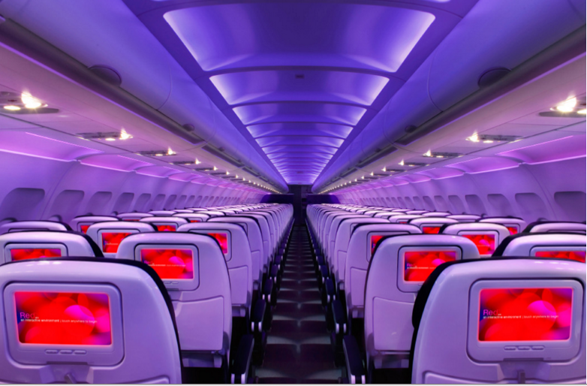

Main Cabin Main Cabin Select First Class

(add links to Cabin Class Pages)

Ready. Set. Fly.

Book your Mood-lit Ride to Colorado Springs.

When planning your trip to Colorado Springs, think about spending some time in Denver beforehand. Instead of taking direct flights to Colorado Springs, when you book a flight to Denver International Airport with Virgin America, you’ll be able to explore Denver’s unique downtown, visit the aquarium or catch a Colorado Rockies game at Coors Field. Then you can set off on the short drive to Colorado Springs to continue your traveling adventures. From our spacious seats with personal outlets, to our on-demand food ordering, you’ll be impressed with all that our in-flight experience offers.

Take a Virtual Tour

Add Terms & Conditions